LOYOLA COLLEGE (AUTONOMOUS), CHENNAI – 600 034
M.A. DEGREE EXAMINATION - ENGLISH LITERATURE
FOURTH SEMESTER – APRIL 2011

EL 4952 - TRANSLATION

Date : 15-04-2011 Dept. No. Max. : 100 Marks

Time : 1:00 - 4:00

SECTION - A

I Answer any FOUR of the following in about 100 words each. (4x5=20)

- Interlingual and intralingual translation
- Types of Translation.
- Untranslatability in Translation
- Bible Translation
- Translation of poetry
- Literary translation and Technical translation

II Answer any THREE of the following in about 250 words each. (3x10=30)

- Translation problems and solutions.
- Translation and Sociolinguistics
- Translation of Prose texts
- Various approaches to translation
- Translation equivalences

SECTION - B

1)Translate the following POEM into Tamil (10)
Each word I have written has come to me from above,
It was not mine;
It was the Inspiration of the Love,
I do not know any metre, I do not go by any rule…
My kind of verse is never taught in schools,
I never sat on a chair..
Planning before wielding my pen,
But all words of mine came,
Spontaneous, sudden and with a rush
So these outpourings, these offerings,
Whether Good or Bad, whether you like them or
They make you mad or sad,
Were not created by me… true! Were not mine
I was just the Goblet, She poured in the wine
So don’t give me the laurel wreath
Or crucify me in a cross…
It was something beyond me
Which turned into light what was once dross.
- Sandeep Singh-
2) Translate the following Tamil article into English: (10)
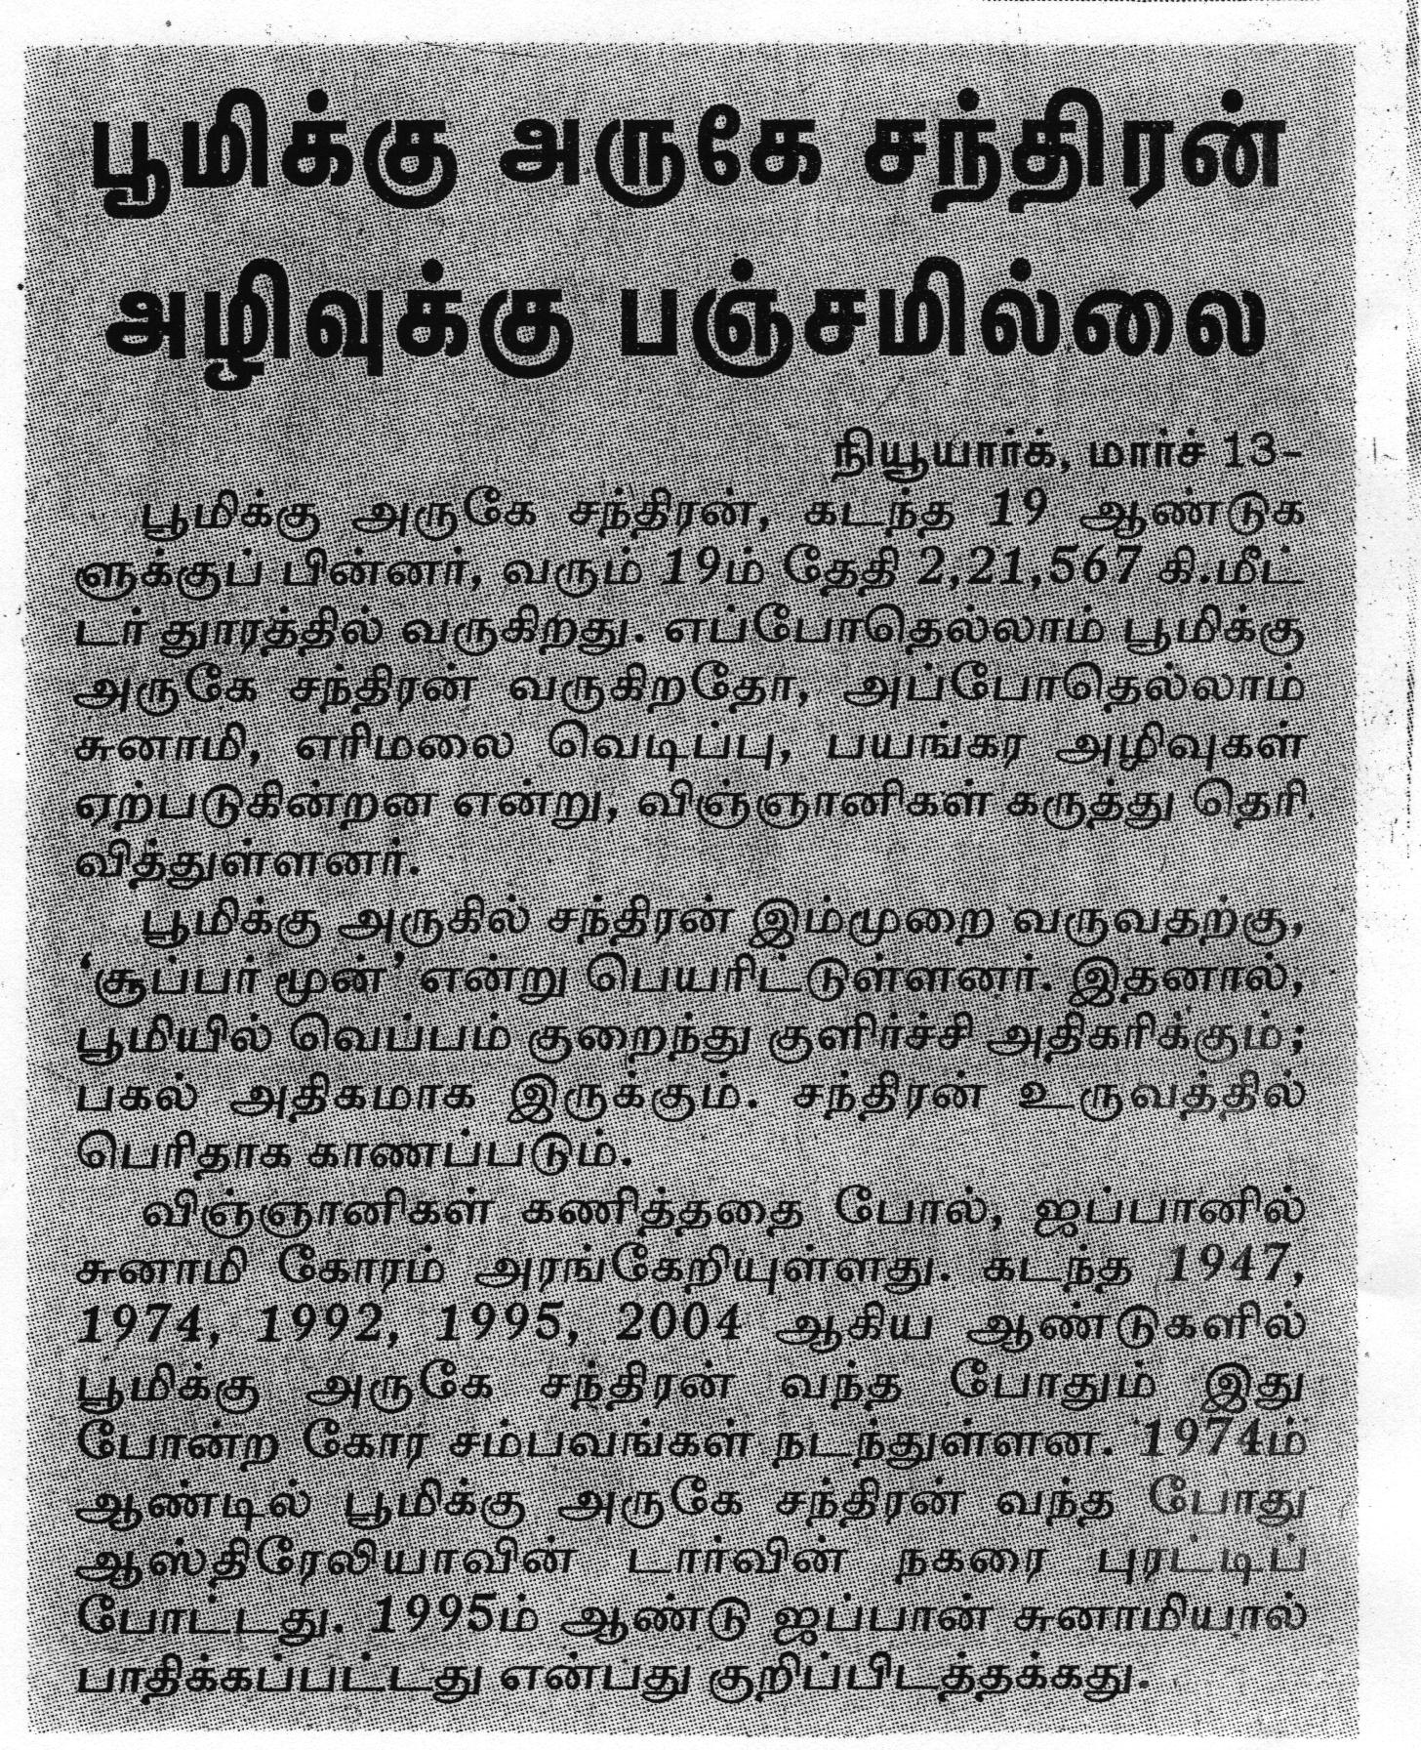

3) Translate the following English excerpt into Tamil (10)
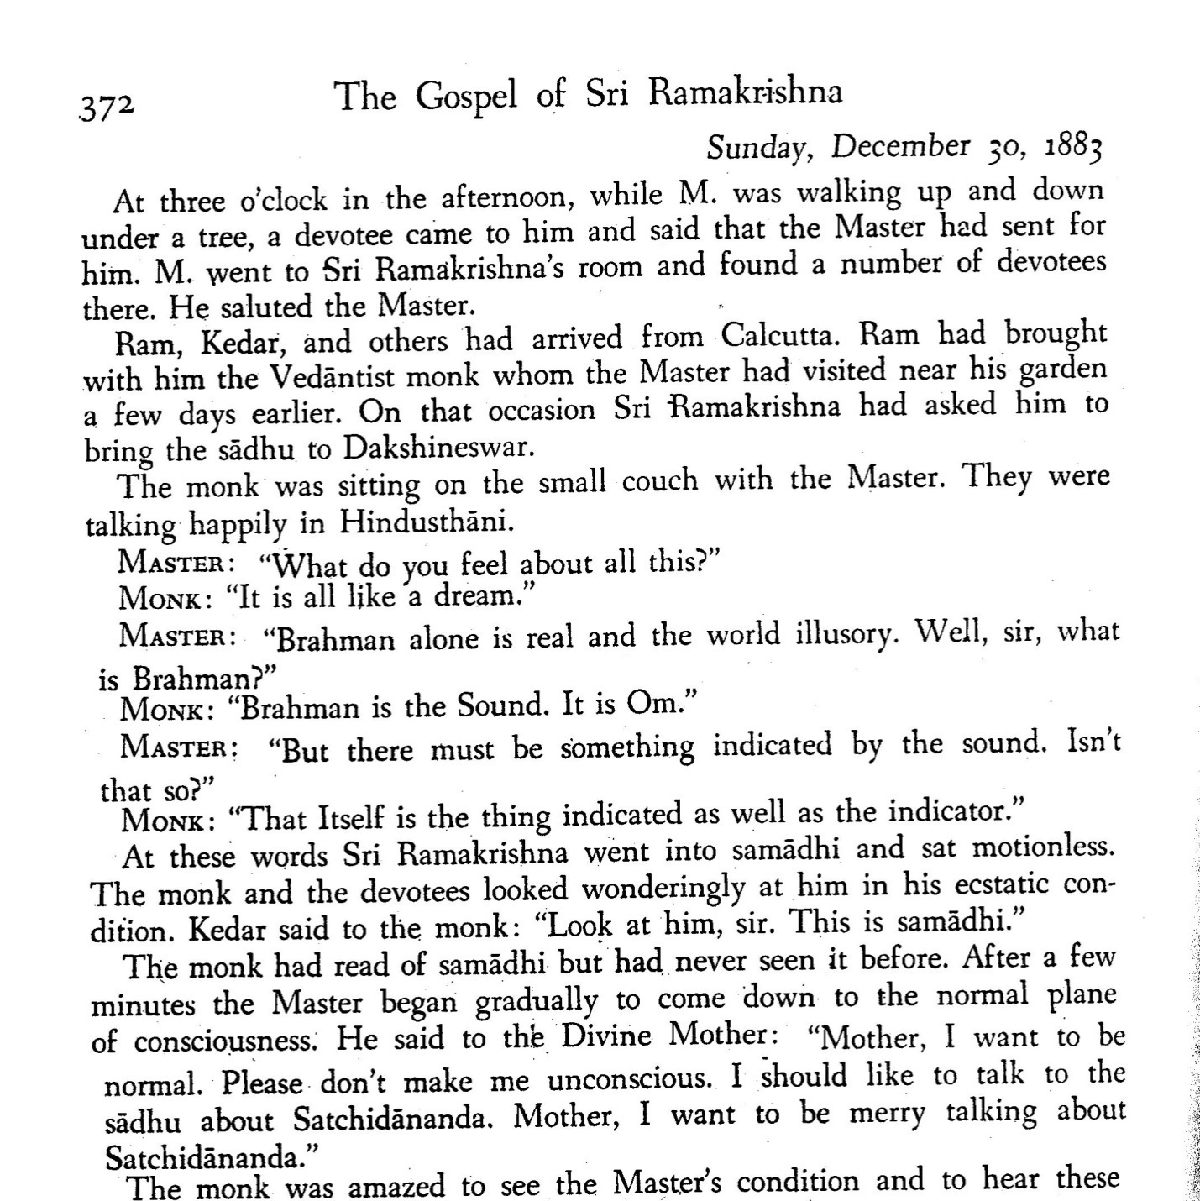

4)Translate the following Tamil short story into English: (10)

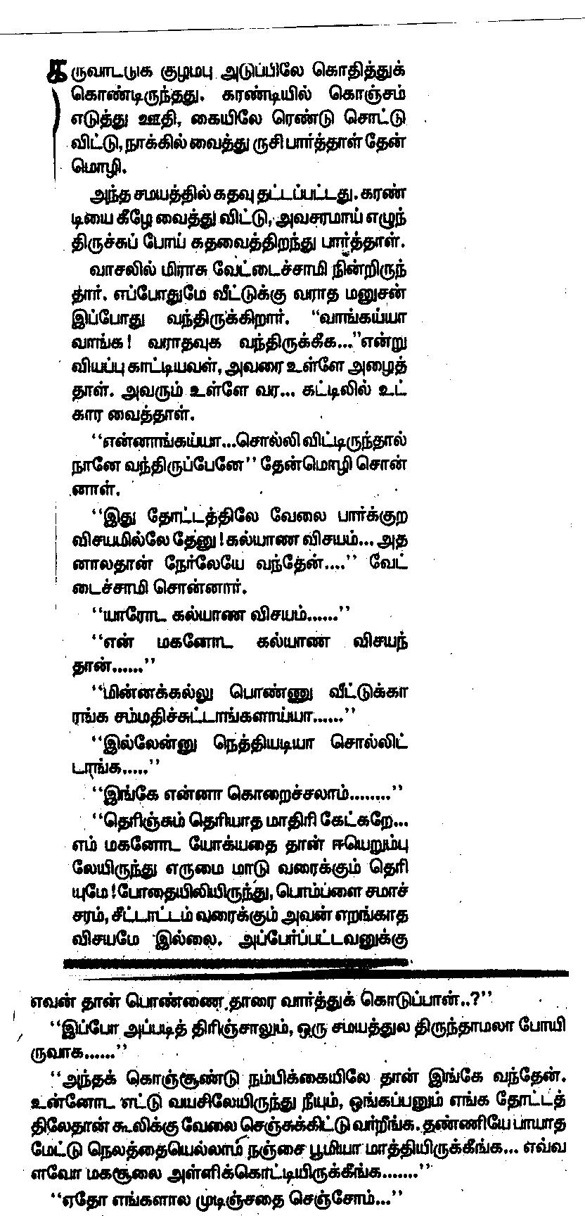
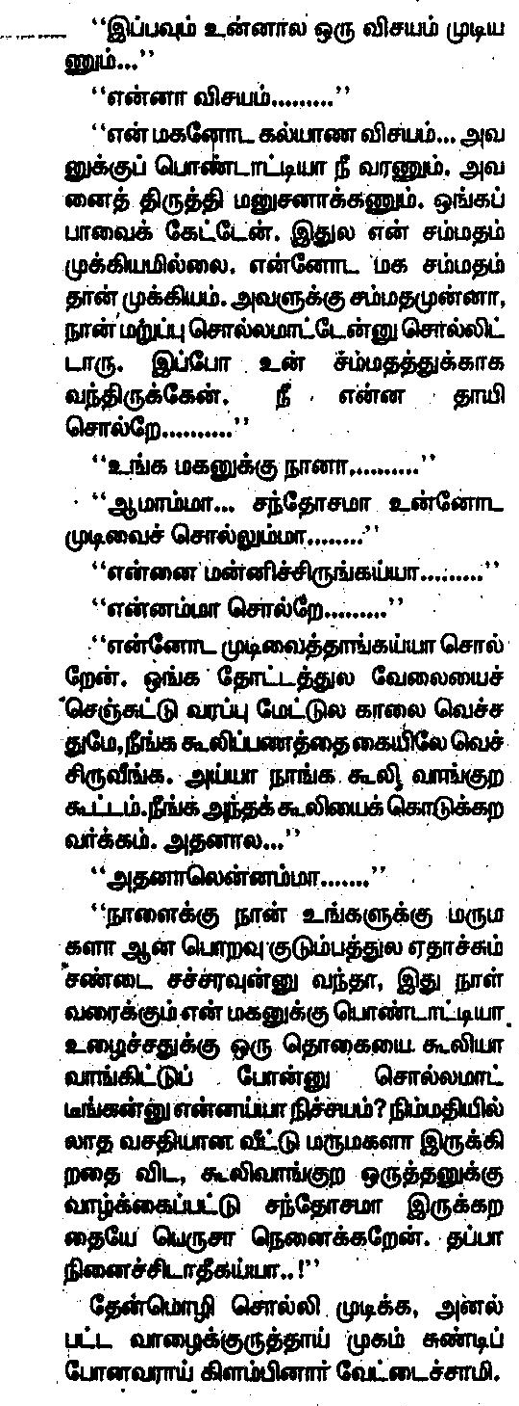

5)Translate the following Quotations into Tamil: (5)
a) A prudent question is one half of wisdom.
b) By the time a man realizes that maybe his father was right, he usually has a son who thinks he's wrong.
c) Common sense and a sense of humor are the same thing, moving at different speeds. A sense of humor is just common sense, dancing. And a joke is a very serious thing.
d) “Character is not cut in marble; it is not something solid and unalterable. It is something living and changing...”
e) Every person, all the events of your life are there because you have drawn them there. What you choose to do with them is up to you. Here is a test to find out if your mission on earth is finished: If you're alive, it isn't.
6) Translate the following Tamil tidbit into English(5)
